SPECIAL NOTE FOR DRY-LAID ROCK FENCES

This Special Note will apply when indicated on the plans or in the proposal. Section references herein are to the Department’s Current Standard Specifications for Road and Bridge Construction.

1.0 DESCRIPTION. Preparation and construction of dry-laid rock fences.

2.0 MATERIALS. Move, store, and supply the rock at no expense to the Department. When relocating or repairing existing fences, use the original rock whenever possible. Dismantle existing fences manually or by methods that do not contaminate the rock with soil.

3.0 CONSTRUCTION. Lay out the fence line in advance to provide continuity in its appearance. Construct in close conformance to Figure 1. If the height of the fence differs from Figure 1, maintain a 1:6 batter.

Figure 1

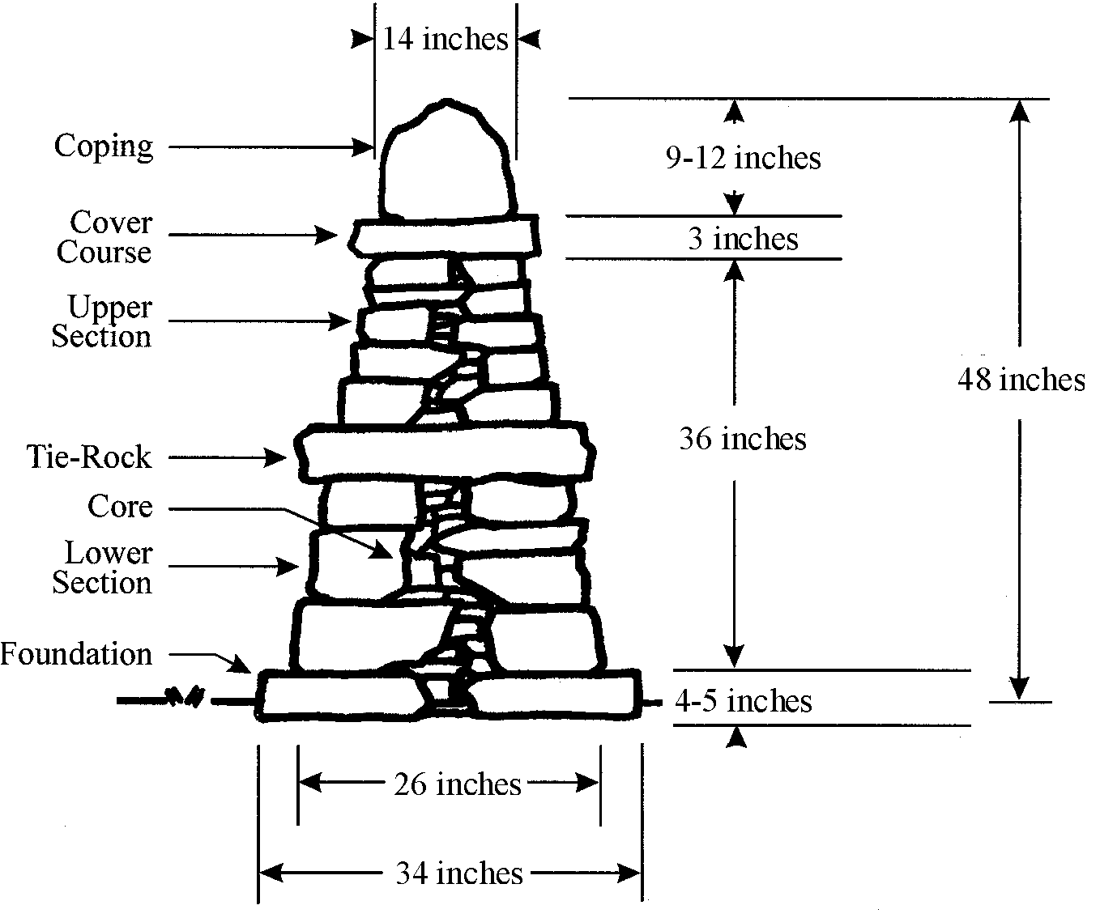

3.1 Subgrade. Level and compact the subgrade. Remove all organic matter.

3.2 Foundation. Place foundation stones so their upper surfaces are level and lower surfaces are fully supported by the subgrade or through stone underpinning. Underpinning from the front is unacceptable. Assure that more than half of the width of each foundation stone extends under the lower course.

3.3 Core. Use large stone when practical and continue with smaller stone until all gaps are filled. Interlock stones as much as possible.

3.4 Lower Course. Use the larger face stone on the lower course. Place so joints are overlapped. Point the long side of the stone in whenever possible. Fully support all face stones. Build one layer at a time, pack and level the core simultaneously. Level the lower course at 18 inches above the foundation for the tie rocks.

3.5 Tie Rocks. Place on 36-inches centers. Overlap lower course joints whenever possible. Use single stones that overhang the leveled lower course by 2 to 4 inches on both sides of the fence. Fully support all tie rocks.

3.6 Upper Coarse. Continue to place face stones around and over the tie rocks as on the lower course. Level the upper course at 3 feet above the foundation for the cover course.

3.7 Cover Course. Use single stones that overhang the leveled upper course by 2 to 3 inches. Fully support all cover stones.

3.8 Coping. Place a single cope on top of the cover course. Use stones that do not overhang the cover course. Angle the cope stones at 15 degrees sloping downhill. Keep the top surface of the cope at a leveled height between 9 and 12 inches. Drive in stone pins to level and lock in the cope. If requested by the landowner, the Engineer may require a double cope (figure 2). If a double cope is used, widen the fence from the foundation up to accommodate.

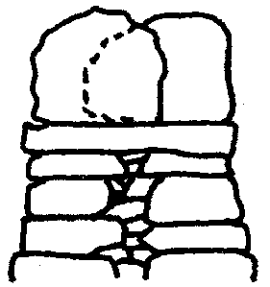
Figure 2

3.9 Pinning. Pin only when support is needed, not for appearance. Avoid using multiple pins, use one stone for one hole.

3.10 Wallheads. End fences with flush vertical wallheads using large stone for stability. Construct in close conformance to Figure 3.

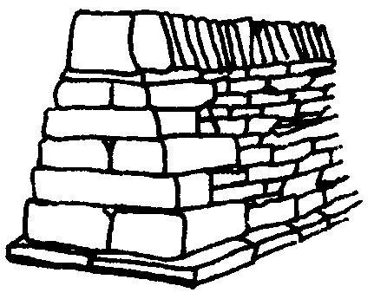
Figure 3

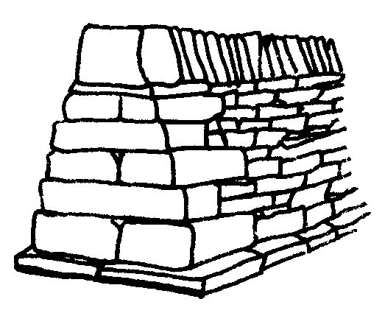
4.0 MEASUREMENT. The Department will measure the quantity of dry-laid rock fence in linear feet.

5.0 PAYMENT. The Department will make payment for the completed and accepted quantities under the following:

Code Pay Item Pay Unit
20063EN9T Dry-laid Rock Fence Linear Feet

The Department will consider payment as full compensation for all work required in this provision.

April 29, 2021

